CSA0613-DAA
NAME : Kailash.S – 192524018
CO1 AT1
Q1. Application: Online Video Streaming Platform
A video streaming platform processes user data using an algorithm with recurrence T(n) =
2T(n/2) + n. Apply the Master Theorem to determine the time complexity. Clearly identify
parameters and justify the selected case. Analyze how this affects scalability as users
increase. Interpret efficiency using asymptotic notation.
Souce code :
import math

def master_theorem(a, b):
value = math.log(a, b)
print("Master Theorem Analysis")
print("-----------------------")
print("a =", a)
print("b =", b)
print("n^(log_b a) = n^", value)

if value == 1:
print("Case 2 applies")
print("Time Complexity = Theta(n log n)")
else:
print("Different case")

master_theorem(2,2)

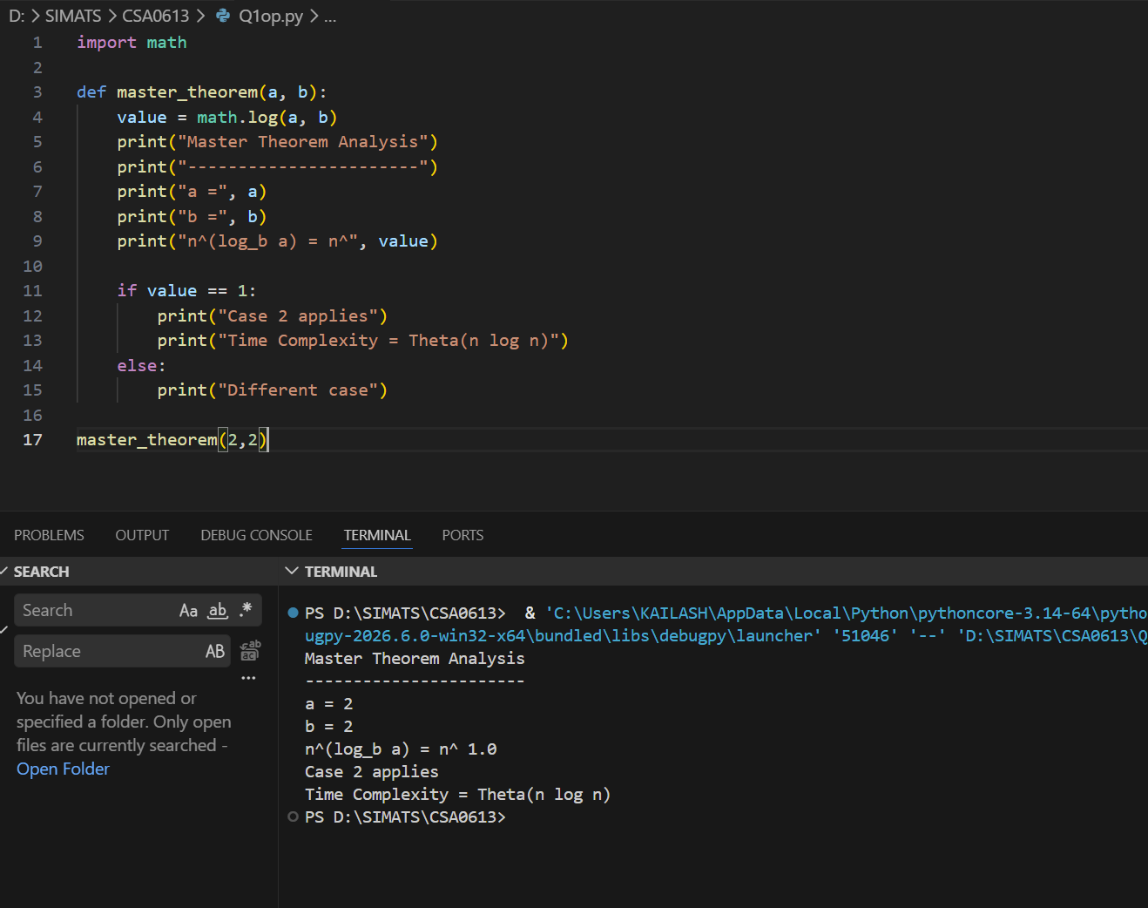
Recurrence
$$T(n)=2T(n/2)+n$$

Step 1: Identify Parameters
Compare with
$$T(n)=aT(n/b)+f(n)$$
Therefore
- a = 2
- b = 2
- f(n)=n
Step 2: Compute
$$n^{{log⁡}_{b}a} \\ =n^{{log⁡}_{2}2} \\ =n^{1}=n$$
Now compare
$$f(n)=n$$
and
$$n^{{log⁡}_{b}a}=n$$
Both are equal.
Step 3: Select Master Theorem Case
Since
$$f(n)=Θ(n^{{log⁡}_{b}a})$$
Master Theorem
Case 2
Step 4: Final Complexity
$$T(n)=Θ(nlog⁡n)$$
Scalability Analysis
As users increase,
- video requests double
- algorithm divides work into two equal halves
- combines results in linear time
Overall growth
$$Θ(nlog⁡n)$$
which is efficient for large-scale streaming systems.
Asymptotic Interpretation
Upper Bound
$$O(nlog⁡n)$$
Lower Bound
$$Ω(nlog⁡n)$$
Tight Bound
$$Θ(nlog⁡n)$$Q14. Application: Distributed Sensor Network Analysis
A sensor network algorithm divides a monitoring problem into three equal subproblems and
performs only constant work at each level for control operations. Apply the substitution
method to solve the recurrence T(n)=3T(n/3)+1. Show all intermediate steps and derive the
final asymptotic complexity. Analyze how this algorithm scales with increasing sensor nodes.
Interpret the efficiency using asymptotic notation.
SOURCE CODE :
import math

def substitution(n):
print("Substitution Method")
print("-------------------")
print("Recurrence: T(n)=3T(n/3)+1")
print("Levels =", int(math.log(n,3)))
print("Final Complexity = Theta(n)")

substitution(81)
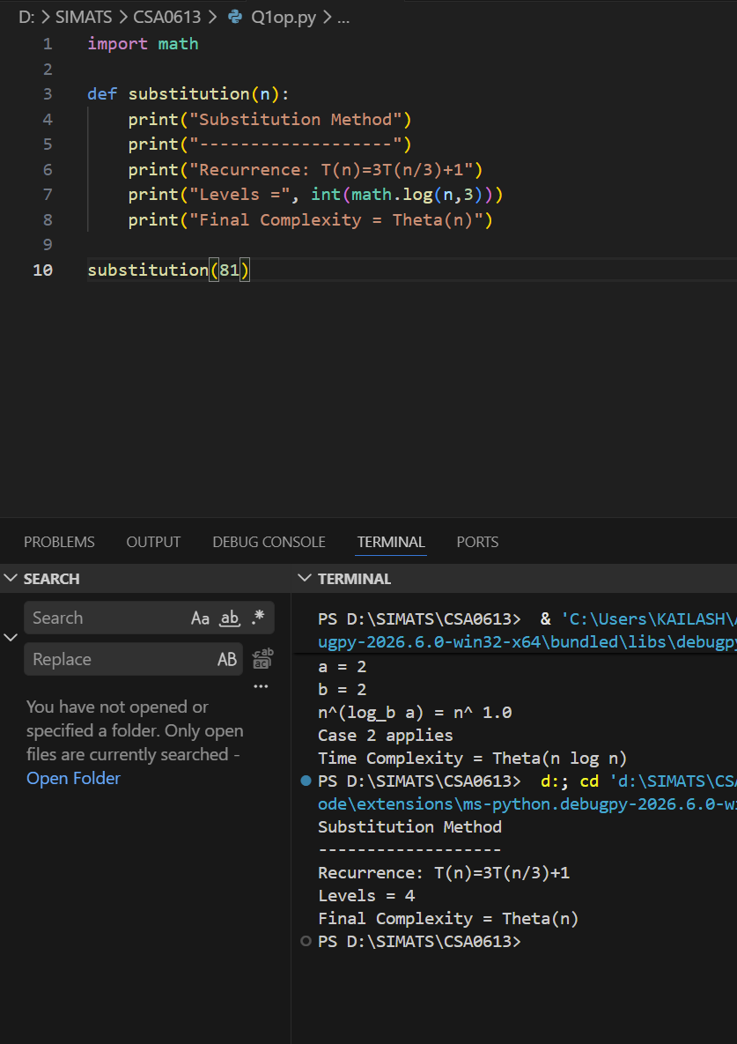
Recurrence
$$T(n)=3T(n/3)+1$$
Use the Substitution Method.
Step 1
Given
$$T(n)=3T(n/3)+1$$
Expand once
$$=3\left(3T(n/9)+1\right)+1 \\ =9T(n/9)+3+1 \\ =9T(n/9)+4$$
Expand Again
$$=9\left(3T(n/27)+1\right)+4 \\ =27T(n/27)+9+4 \\ =27T(n/27)+13$$
General Expansion
After k expansions
$$T(n)=3^{k}T(n/3^{k})+\sum_{i=0}^{k-1}{3^{i}}$$
Stopping Condition
When
$$\frac{n}{3^{k}}=1$$
Therefore
$$3^{k}=n \\ k={log⁡}_{3}n$$
Substitute
Since
$$3^{k}=n \\ T(n)=nT(1)+\frac{3^{k}-1}{2}$$
Assume
$$T(1)=1$$
Then
$$T(n)=n+\frac{n-1}{2}$$
Ignoring constants
$$T(n)=Θ(n)$$
Final Complexity
$$\boxed{Θ(n)}$$
Scalability Analysis
Each recursive level performs only constant work.
Although three recursive calls are made,
the problem size becomes one-third each time.
Overall work grows linearly with sensor nodes.
Thus
$$Θ(n)$$
Asymptotic Interpretation
Upper Bound
$$O(n)$$
Lower Bound
$$Ω(n)$$
Tight Bound
$$Θ(n)$$

